***…WOW, full !***

**Title Captive on SDGC**

**Watermaker to SDG Y.x**

**SDG Y.x what get by SDGC ? (Solar Desalination Geoassited Continuous)**

**Watermaker – SDGC toward SDGs/UN Y.x** (Target Y.x - …By 2030, ensure universal access to affordable, reliable and modern energy services).

Summary

**J W T 2**

**Bibliography/Conclusion 2**

Watermaker from SDGC (source) : 3

Summary – Applications (to SDGs) 5

International Application Status Report 11

# J W T

### [****joules****](http://www.expotv1.com/JWT_project.pdf) [****water team****](http://www.expotv1.com/JWT_project.pdf)

[***https://www.jwt-jwt.it/***](https://www.jwt-jwt.it/)

**Subject to the NDA, consultancy and appropriate industrial property rights are available**

( [**INNOVATION**](http://www.expotv1.com/LIC/BUNIT/LISTV.ASP) - [Patents and Projects, with relevant BPs and StartKit Commercial Offers](http://www.expotv1.com/LIC/BUNIT/LISTV.ASP)  )

**JWTeam**

<http://www.expotv1.com/ESCP_NUT_Team.pdf>

*Offers extensive support on* ***Energy*** *and* ***Water Cycle,*** *verse* [**IP_S DGs /UN**](http://www.expotv1.com/JWT_to_SDG_UN.pdf)

# Bibliography/Conclusion

Any reference to people and things is purely coincidental, as well as creative/imaginative and aimed at the common good (both in fiction and non-fiction/disclosable texts). The Owners/Inventors of the Editorial rights on the source Intellectual Property believe the contents do not misrepresent the essential objectives, aimed to disclose, but above all promote the official sources cited in the bibliographies. Patents are archived, granted and owned by authors who have issued the necessary editorial permissions. Each patent is well founded (legitimized by the relevant national legal bodies: UIBM/IT, EPO/EU, WIPO/UN, EAPO/RU, CNIPA/CN, InPASS/IN), well understandable to professionals, and usable according to case law in vogue; [**JWTeam**](http://www.expotv1.com/ESCP_NUT_Team.pdf) reviews and oversees the dissemination of [**SDGs/UN**](https://sdgs.un.org/goals), pronouncing itself with the pseudonym "**Ghost GREEN**".

# Watermaker from SDGC (source) :

Patent:

[**SDGC**](http://www.expotv1.com/LIC/UIBM_SDGC.pdf) ,    [**https://patentscope.wipo.int/search/en/detail.jsf?docId=WO2016162896**](https://patentscope.wipo.int/search/en/detail.jsf?docId=WO2016162896) (sea and process water solar desalination);  [view1](https://www.bing.com/images/search?q=%28sea+and+process+water+solar+desalination%29+&FORM=HDRSC2)

Italy: GRANT

<http://www.expotv1.com/LIC/MISE_0001429306_SDGC.pdf>, ... mean "INDUSTRY (useful), NEW (no make before), INVENTIVE (teach some things)".

**Abstract/Description -** Patent:

[**SDGC**](http://www.expotv1.com/LIC/UIBM_SDGC.pdf),[**https://patentscope.wipo.int/search/en/detail.jsf?docId=WO2016162896**](https://patentscope.wipo.int/search/en/detail.jsf?docId=WO2016162896)

**Full Intellectual Property**

[**http://www.expotv1.com/ESCP_Patent.htm**](http://www.expotv1.com/ESCP_Patent.htm)

**Full JWTeam Service –**

[**http://www.expotv1.com/PUB/JWT_Service_EN.pdf**](http://www.expotv1.com/PUB/JWT_Service_EN.pdf)

# Summary – Applications (to SDGs)

[**SDGC**](http://www.expotv1.com/LIC/UIBM_SDGC.pdf)

[**https://patentscope.wipo.int/search/en/detail.jsf?docId=WO2016162896**](https://patentscope.wipo.int/search/en/detail.jsf?docId=WO2016162896)

**Water – great efficiency in DESALINING with renewable sources. SDGC** is dedicated to desalination (of sea water, brackish water or bodies of water to be reclaimed), has the advantage of using only renewable energy and with performance indices comparable to Reverse Osmosis (dependent on fossils);　the system is scalable from small to large installations, offering the possibility of implementing distributed **& pervasive** and counteracting critical logistics issues (often a serious problem). An infrastructural supply of "fresh" water towards the general plant engineering industry and in particular that for　the production of hydrogen. Drastic action towards the Inorganic load,　contributing to the performance on　" **Water cycle** ".

**Project:**

SDGC – Solar Desalination Geoassisted Continuous

**Objective :** Launch an assembly and testing site (procedures and manuals) for the production of SDGC tanks (of assorted cuts and functions, reclamation of water bodies or production for food purposes).

**Target:** Prefabricated and container companies, hydromechanics , financial investors, operators in the fresh water sector, purification operators

The project aims to activate a production site, from design to assembly (pro delivery and rapid assembly), with the development of production-oriented procedures agreed with the client (based on the available inputs) and the destinations of the outputs produced. The solutions rely on standard products from the water management and prefabricated market (including containers), assembled and tested with a view to optimizing distillation using solar energy and support from thermal gradients. In collaboration with internal and external laboratories, it will act as remote support for the installations in charge (EPC - Engineering , Procurement and Construction ).

**Summary:** This invention talks about how a machine can remove salt from sea water, salt water or water that comes from factories. This machine can use energy that comes from the sun, wind or underground. To remove salt from water, you need to make the water turn into steam and then turn it back into water (all at usual thermal conditions, for example how dew is produced). We plan to proceed as follows:

• put the water in a closed tank where the steam will be produced;   
• heat the water near the surface, so it produces more steam;   
• causes the steam to become water again, encountering colder surfaces (expanded metal arranged in a fan), adjacent to parts to which they will release the heat to even colder but liquid parts, fueling the convective motions in the liquid part, which then traces and reiterates the process;

• collects the condensed water, without salts, in suitable reservoirs and from which it is taken.

The machine is a well-insulated tank, into which water is introduced in continuous processes. Inside the tub there are devices that heat the water to make it steam. There are also means that turn the steam back into water and that collect the water without salt, transferring the energy by-passing critical areas (the key to conservation and reduced need for energy). These means are made like this:   
  
• the tank is filled with water up to a certain point (approximately 2/3), so the condensation process is completed in the empty space above;

• the half -radiators, which heat the water , are close to the surface of the water and will be powered by natural sources (possibly supported by heat pumps);   
• the means that create water vapor are on the surface of the water and heat in a limited way, inside the water, thus giving off a lot of heat;

• from the proposed reservoirs, the condensed water (which arrives by gravity and free of any salt) is taken from the coldest surfaces encountered, similar to the temperature regimes of storm processes in the tropics.

The machine uses the available renewable energy well , both solar and environmental conditions, fueling convective motions, both in the aerial and liquid parts, taking care not to lose energy, thanks to adequate insulation and prepared exchangers; The machine can use both energy that comes from the sun, wind or underground, and energy that comes from other sources. This machine is used to make clean (distilled) water, useful for many things: for factories, for plants, for animals and also for people (suitably integrated with the desired salts for drinking and nothing for industries, which they like even less – hard waters). This machine can help remove countless impurities resulting from many industrial and anthropic processes in general. In an indirect way, therefore, to remedy many ongoing social disparities in many communities .

[***SDGs / UN_en***](https://sdgs.un.org/goals) ***-*** [***SDGs / UN_it***](https://sdgs-un-org.translate.goog/goals?_x_tr_sl=en&_x_tr_tl=it&_x_tr_hl=it&_x_tr_pto=wapp) ***Full Strategy to***

[***1***](https://sdgs.un.org/goals/goal1)[***2***](https://sdgs.un.org/goals/goal2)[***3***](https://sdgs.un.org/goals/goal3)[***4***](https://sdgs.un.org/goals/goal4)[***5***](https://sdgs.un.org/goals/goal5)[***6***](https://sdgs.un.org/goals/goal6)[***7***](https://sdgs.un.org/goals/goal7)[***8***](https://sdgs.un.org/goals/goal8)[***9***](https://sdgs.un.org/goals/goal9)[***10***](https://sdgs.un.org/goals/goal10)[***11***](https://sdgs.un.org/goals/goal11)[***12***](https://sdgs.un.org/goals/goal12)[***13***](https://sdgs.un.org/goals/goal13)[***14***](https://sdgs.un.org/goals/goal14)[***15***](https://sdgs.un.org/goals/goal15)[***16***](https://sdgs.un.org/goals/goal16)[***17***](https://sdgs.un.org/goals/goal17)[**SDGs/UN**](http://www.expotv1.com/JWT_to_SDG_UN.pdf)

[***http://www.expotv1.com/ESCP_Hello.htm***](http://www.expotv1.com/ESCP_Hello.htm)

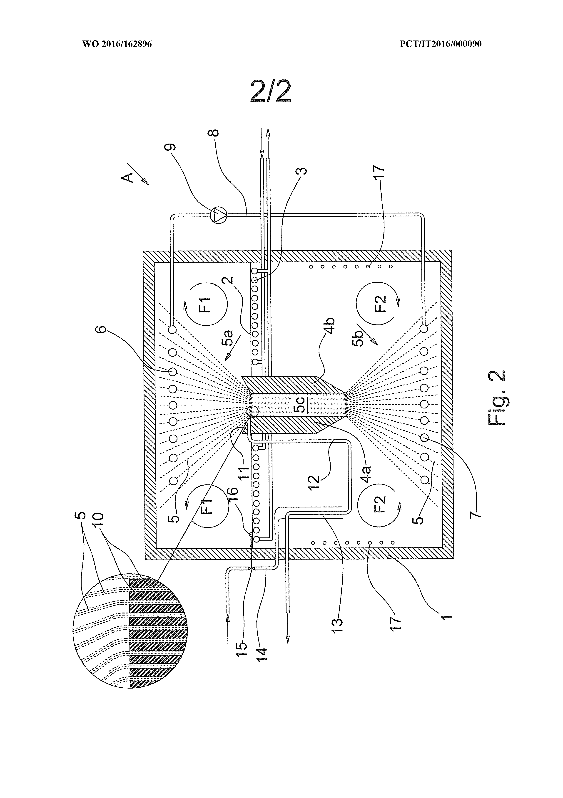

# IASR International Application Status Report

Received at International Bureau: 14 June 2016 (14.06.2016)

Information valid as of: 13 September 2016 (13.09.2016)

Report generated on: 28 September 2023 (28.09.2023)

(10) Publication number: (43) Publication date: (26) Publication language:

WO 2016/162896 13 October 2016 (13.10.2016) English (EN)

(21) Application number: (22) Filing date: (25) Filing language:

PCT/IT2016/000090 11 April 2016 (11.04.2016) Italian (IT)

(31) Priority number(s): (32) Priority date(s): (33) Priority status:

MI2015A000505 (IT) 09 April 2015 (09.04.2015) Priority document received (in compliance with PCT Rule 17.1)

(51) International Patent Classification:

B01D 5/00 (2006.01); B01D 1/00 (2006.01); B01D 1/30 (2006.01); C02F 1/14 (2006.01)

(71) Applicant(s):

LAVANGA, Vito [IT/IT]; Via Terrazzano 85 I-20017 Rho (Ml) (IT) (for all designated states)

(72) Inventor(s):

LAVANGA, Vito; Via Terrazzano 85 I-20017 Rho (Ml) (IT)

FARNE', Stefano; Via Trasimeno 40/14 20128 - Milano (Ml) (IT)

(54) Title (EN): METHOD FOR THE CONTINUOUS DESALINIZATION AND DEVICE FOR THE IMPLEMENTATION OF SAID METHOD

(54) Title (FR): PROCÉDÉ POUR LA DÉSALINISATION CONTINUE ET DISPOSITIF POUR LA MISE EN ŒUVRE DUDIT PROCÉDÉ

(57) Abstract:

(EN): This invention refers to a method and a device for desalinating sea water, brackish water or from industrial processes. The device is suitable to use renewable energy sources such as solar or geothermal energy. The device is of the type that includes a tank (1) for the containment of the water to desalinate, in which there are heating means fitted to cause the evaporation of said water to desalinate, cooling means fitted to favour the subsequent condensation of the steam and means fitted to the collection of the condensed water and it is characterized in that: said tank (1), fitted to contain said water to desalinate, is filled up to a certain level (2); said heating means, for evaporating said water include a first heat exchanger (3), immersed in the water to desalinate and positioned nearby said level (2); said cooling means (5a), fitted to cause the condensation of the steam, are in heat exchange connection with the heating means (5b), immersed in said water to desalinate, said heat exchange simultaneously causing: a) the reduction of the temperature of said means (5a), therefore the suitable conditions for the condensation of the steam; b) the increase in temperature, into the depths, of said water to desalinate.

(FR): La présente invention concerne un procédé et un dispositif de désalinisation d'eau de mer, d'eau saumâtre ou provenant de processus industriels. Le dispositif est approprié pour l'utilisation de sources d'énergie renouvelable, telles que l'énergie solaire ou géothermique. Le dispositif est du type comprenant un réservoir (1) pour le confinement de l'eau à dessaler, dans lequel se trouvent un moyen de chauffage conçu pour provoquer l'évaporation de ladite eau à dessaler, un moyen de refroidissement conçu pour favoriser la condensation ultérieure de la vapeur et un moyen conçu pour collecter l'eau condensée, et est caractérisé en ce que : ledit réservoir (1), conçu pour contenir ladite eau à dessaler, est rempli jusqu'à un certain niveau (2); ledit moyen de chauffage, conçu pour provoquer l'évaporation de ladite eau à dessaler, comprend un premier échangeur de chaleur (3) immergé dans l'eau à dessaler et positionné à proximité dudit niveau (2); ledit moyen de refroidissement (5a), conçu pour provoquer la condensation de la vapeur, est en liaison d'échange thermique avec le moyen de chauffage (5b) immergé dans ladite eau à dessaler, ledit échange de chaleur provoquant simultanément : a) la baisse de la température dudit moyen (5a), et par conséquent les conditions appropriées pour la condensation de la vapeur; b) l'augmentation de la température, dans les profondeurs, de ladite eau à dessaler.

International search report:

Received at International Bureau: 12 September 2016 (12.09.2016) [EP]

International Report on Patentability (IPRP) Chapter II of the PCT:

Not available

(81) Designated States:

AE, AG, AL, AM, AO, AT, AU, AZ, BA, BB, BG, BH, BN, BR, BW, BY, BZ, CA, CH, CL, CN, CO, CR, CU, CZ, DE, DK, DM, DO, DZ, EC, EE, EG, ES, FI, GB, GD, GE, GH, GM, GT, HN, HR, HU, ID, IL, IN, IR, IS, JP, KE, KG, KN, KP, KR, KZ, LA, LC, LK, LR, LS, LU, LY, MA, MD, ME, MG, MK, MN, MW, MX, MY, MZ, NA, NG, NI, NO, NZ, OM, PA, PE, PG, PH, PL, PT, QA, RO, RS, RU, RW, SA, SC, SD, SE, SG, SK, SL, SM, ST, SV, SY, TH, TJ, TM, TN, TR, TT, TZ, UA, UG, US, UZ, VC, VN, ZA, ZM, ZW

European Patent Office (EPO) : AL, AT, BE, BG, CH, CY, CZ, DE, DK, EE, ES, FI, FR, GB, GR, HR, HU, IE, IS, IT, LT, LU, LV, MC, MK, MT, NL, NO, PL, PT, RO, RS, SE, SI, SK, SM, TR

African Intellectual Property Organization (OAPI) : BF, BJ, CF, CG, CI, CM, GA, GN, GQ, GW, KM, ML, MR, NE, SN, TD, TG

African Regional Intellectual Property Organization (ARIPO) : BW, GH, GM, KE, LR, LS, MW, MZ, NA, RW, SD, SL, ST, SZ, TZ, UG, ZM, ZW

Eurasian Patent Organization (EAPO) : AM, AZ, BY, KG, KZ, RU, TJ, TM

Declarations:

Declaration made as applicant's entitlement, as at the international filing date, to apply for and be granted a patent (Rules 4.17(ii) and 51bis.1(a)(ii)), in a case where the declaration under Rule 4.17(iv) is not appropriate

Declaration of inventorship (Rules 4.17(iv) and 51bis.1(a)(iv)) for the purposes of the designation of the United States of America

